

Visiting Lecturers School of Design

October 2026

About West Dean

West Dean is a unique place to work and visit, combining an internationally recognised centre for arts, design, craft, and conservation with award-winning public gardens, historic collections, and a working estate.

In Sussex, our campus is set within the 6,350-acre West Dean Estate in the South Downs National Park. It is home to West Dean College, renowned gardens that attract thousands of visitors each year, heritage glasshouses, a kitchen garden, and tranquil parkland walks. The estate also includes a Tapestry Studio and historic staterooms that host events, exhibitions, and private functions.

In London, our Bloomsbury campus is home to the prestigious KLC School of Design, offering students access to inspiring studio spaces and is surrounded by world-class museums, galleries, and theatres.

Together, our two campuses bridge countryside and city life, offering a rich mix of education, heritage, hospitality, and visitor experiences. Working at West Dean means joining a community that values creativity, craftsmanship, sustainability, and inclusivity, while playing a part in safeguarding and sharing one of the UK’s most distinctive cultural institutions.




About The Role

As a visiting Lecturer, you will contribute to planning and delivering an engaging and contemporary design curriculum across our BA, Diploma, and Certificate programmes, both on-site and on-line.
Working closely with the Programme Leader and wider academic team, you will inspire students through high-quality teaching, practical demonstrations, tutorials, and assessment, helping them to develop both the technical expertise and creative confidence needed to thrive within the design industry. You will bring current professional knowledge and a passion for design education, ensuring that learning remains relevant, innovative, and reflective of contemporary practice. The successful candidate will work closely with colleagues across academic, technical, and student support teams to create a positive, inclusive, and professionally focused learning environment.

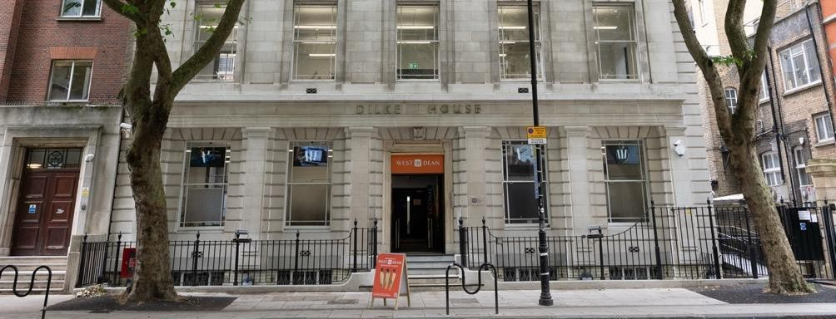
This is a rewarding role for a creative practitioner who is committed to nurturing emerging talent, building meaningful industry connections, and contributing to a vibrant academic community where innovation, collaboration, and creative exploration are at the heart of everything we do.

Job Description


JOB TITLE Visiting Lectures
SCHOOL School of Design
LOCATION Bloomsbury, London
REPORTING TO Programme Leader
SALARY RANGE Day rate dependent on experience, plus reasonable pre-agreed expenses
HOURS Seasonal work with no guaranteed hours. Teaching days will be offered according to curriculum requirements and available teaching needs. The exact dates and number of days will be agreed in advance based on the programme and gaps in the teaching timetable.

PROGRAMME ORGANISATION, MANAGEMENT & ENHANCEMENT
- Deliver high-quality teaching on the design programmes and contribute to cross-school curricula as appropriate
- In collaboration with the Programme Leader, and fellow subject tutors, develop, plan and deliver innovative and relevant curricula for the design programmes.
- Support the daily management and smooth running of the studio areas, maintaining a professional and safe working environment.
- Engage in the teaching of design across all levels, ensuring that content remains current, creative, and aligned with programme outcomes.
- Implement effective assessment processes and provide clear, timely feedback in line with the College’s Assessment Policy.
- Ensure students are well-informed about timetables, unit expectations, deadlines, and assessment methods at the start of each term.
- Maintain and update learning materials and timetabling information on the VLE/intranet.
- Provide regular academic tutorials, feedback, and support for student progression and wellbeing.
- Work closely with Academic and Student Services team to ensure consistent and appropriate academic and pastoral support.
- Support the promotion of a positive, inclusive, and student-centred learning culture across the School of Design

Please note: this job description is not designed to cover or contain a comprehensive listing of activities, duties or responsibilities that are required of the employee for this job. Duties, responsibilities and activities may change at any time.

PERSON SPECIFICATION

Education/Qualification
Undergraduate degree in design or related subject area | Essential
Postgraduate degree in design or related subject area | Essential
Postgraduate Qualification (PgCert HE or better) in teaching & learning | Desirable
Fellowship of the HEA/Advance HE | Desirable
Experience
Minimum of 3-years’ experience in teaching and learning relate to design or a related subject | Essential
Experience of professional practice in design or related industry | Essential
Demonstrable experience of developing teaching and learning materials | Essential
Experience of supporting recruitment and admissions in higher education | Essential
Experience of formative and summative assessment and providing supportive and clear feedback to students | Essential
Experience of demonstrating specialist techniques in the production of design work. | Essential
Current, or recently active in, in design practice, or related industry | Desirable
Experience of online teaching and student support | Desirable
Knowledge & Skills
Demonstrable evidence of contemporary practice in design and related subjects | Essential
Knowledge of, and ability to teach, across design, technical, professional practice and communications areas of design | Essential
Ability to organise and plan curriculum, prepare timetables and ensure  timely delivery of teaching & learning | Essential
Strong ability to communicate, verbally and through writing, providing  clear information to students and others | Essential
Awareness of the knowledge and skills required to gain employment in design, and related sectors | Essential
Demonstrable evidence of using different approaches to creative/design  pedagogy | Essential

Competent in the use of Microsoft Office, including Microsoft Teams, to prepare and deliver teaching, as well as undertake administrative tasks as needed | Essential
Competent in the use of Autocad, SketchUp and Adobe Creative Suite; as well as other digital tools used in design practice. | Essential
Understanding of the use of virtual learning environments to support teaching and learning | Desirable
Knowledge of different roles and responsibilities within design, and related sectors | Desirable
Familiarity with Revit and BIM. | Desirable
Personal Characteristics
Outstanding communication skills, capable of building high performing teams, and maintaining professional, positive, and empathetic  relationships with both students and colleagues. | Essential
A professional, flexible, and supportive attitude towards a diverse range of departmental tasks and objectives. | Essential
Highly disciplined, able to work independently with minimal supervision, and capable of maintaining high standards of professional conduct under pressure and against tight deadlines | Essential

General Terms & Conditions

Job Title: Visiting Lecturers

Duties: As attached job description

Location: Bloomsbury, London

Hours: Sessional work with no guaranteed hours. Teaching days will be offered according to curriculum requirements and available teaching needs. The exact dates and number of days will be agreed in advance based on the programme and gaps in the teaching timetable.

Salary: Day rate dependent on experience, plus reasonable pre-agreed expenses. Visiting Lecturers will invoice the Foundation for work completed. Payment will be made in accordance with the Foundation’s standard invoice payment terms.

How to apply
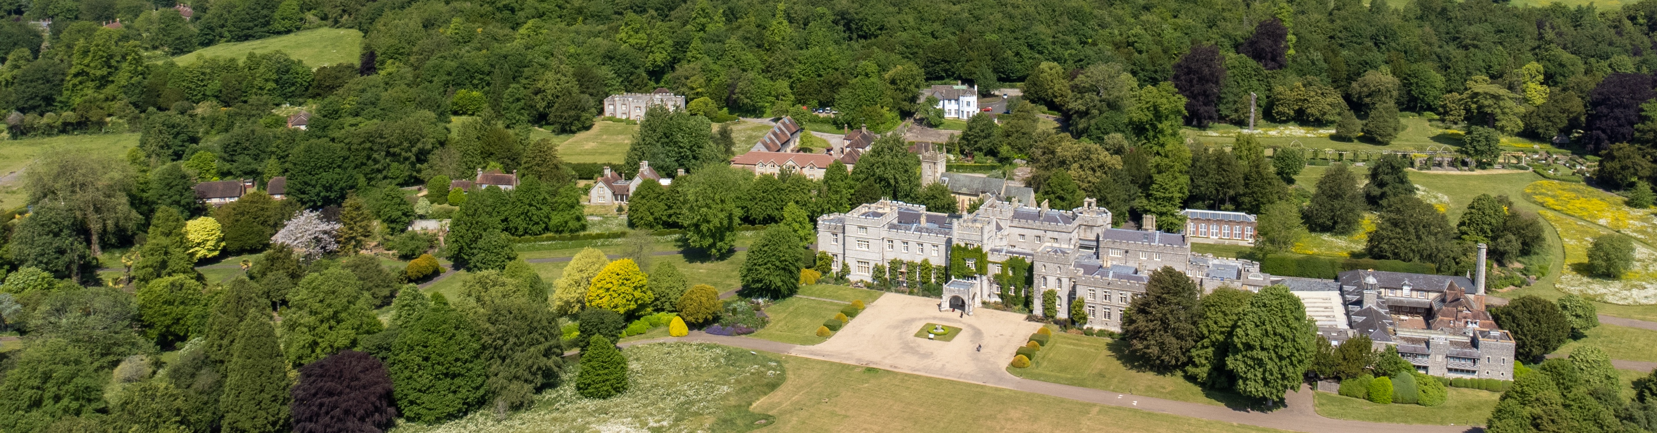

If you are passionate about providing exceptional service, fostering a warm and inclusive environment, we’d love to hear from you! Please apply via our careers site: West Dean Careers or for more information, please contact us on recruitment@westdean.ac.uk

Diversity & Inclusivity Statement

West Dean College values the diversity of its staff and students. We aspire to be a fully inclusive and representative employer and do not condone discrimination on the basis of age, disability, sex, sexual orientation, pregnancy and maternity, faith or ethnicity, religion or belief, gender identity, or marriage and civil partnership. We strongly encourage applications from suitably qualified candidates from a wide range of backgrounds to apply and join our teams at West Dean College.

GDPR Policy Statement

Our GDPR compliant privacy notice for applicants can be viewed by clicking here. By applying for this job, you confirm you have had the opportunity to read our privacy policy and therefore, agree to the terms and conditions contained therein. By applying for this job and sending us your personal data, including your CV, you give us your consent to contact you about this job or any other jobs we feel are suitable. You are able to opt out of us having your data at any time, by contacting the People Department on people@westdean.ac.uk with your request.



Interviews will take place in early-November. Closing date End of October 2026. Early applications advised.
Right to Work in the UK
Please note that this role is not eligible for visa sponsorship. applicants must therefore have the existing right to live and work in the UK.

